PM-3865

Using Linear Programming to Create Optimal Budget Scenarios

Cadence Doyle

# Abstract

Within the National Nuclear Security Administration (NNSA), federal program managers heavily rely on their contractors at Department of Energy (DOE) laboratories to plan their budget. Each site is asked to prioritize investments internally, and communicate those priorities back to the program offices. Federal program managers must weigh competing priorities across all laboratories to make funding decisions. In the NNSA, program managers often wish to eliminate the most risk, which raises the question: “how can the enterprise ensure it is using its dollars to buy down the most amount of risk?”

In this study, we deliver an analytical approach to create optimal budget scenarios. Using linear programming, an operations research technique, we are able to mathematically derive the “optimal” way to spend dollars on the recapitalization of programmatic equipment. Combining the risk score and the procurement cost for each piece of equipment, we translate this business question into a system of linear inequalities. Methods explored in this study do not provide a proposed budget for federal program managers. Instead, they facilitate a data-driven discussion between managers and laboratories. This process will enable federal program managers to make portfolio-wide decisions in an informed manner.

# Table of Contents

Abstract 1

Table of Contents 2

Introduction 3

Linear Programming Overview 4

Simplex Method 5

Literature Review 6

Application 8

Problem Statement and Setup 8

Model Development 11

Results 14

Conclusion 15

References 16

# Introduction

The Department of Energy (DOE) recognizes the need for better program management and prioritization. Years ago, the Government Accountability Office (GAO) released a report saying that multiple offices within the DOE, specifically the National Nuclear Security Administration (NNSA) and the Office of Environmental Management, needed better prioritization to improve facility disposition planning [1]. As recent as 2021, the GAO’s Priority Recommendations for the DOE listed project and program management as the number one issue to address within the department [2]. The GAO also specifically addressed the NNSA, detailing how the NNSA would benefit from an integrated management strategy across the enterprise’s portfolio to manage cost, schedule, and risk [3]. One report specifically stated “DOE historically has struggled with managing programs and projects” [2, p. 2]. To address this issue, DOE has issued various directives and guidance requiring data-driven approaches to program management and prioritization [4] [5].

DOE directives and guidance inform the Planning, Programming, Budgeting, and Execution (PPBE) process to accomplish the Department’s mission, and the NNSA oversees a wide variety of projects and initiatives within that scope. Program managers at the NNSA headquarters plan and direct their missions, but rely on management and operating (M&O) contractors in the field to execute their missions. As M&O contractors are onsite at DOE laboratories, maintaining the safety, security, and effectiveness of the nuclear stockpile, they are the most informed on their facility’s needs and the equipment required to fulfill their duties. The M&O contractors generate their budget requests and investment priorities, and communicate these to the federal program managers.

One federal program manager may have a mission which necessitates assistance from multiple M&O sites. She must put together a single budget request, forcing her to weigh competing priorities. With guidance from the Stockpile Stewardship and Management Plan, the importance of modernizing and innovating with new capabilities often contends with the recapitalization of existing assets [6]. In this context, recapitalization refers to refurbishment or replacement of equipment that directly supports a program’s mission, or programmatic equipment.

There are additional issues surrounding the recapitalization of programmatic equipment. Program managers at headquarters and M&O contractors often have vastly different interpretations of recapitalization scope, leading to miscommunication, resulting in funding redundancies. The Programmatic Recapitalization Working Group (PRWG) was founded to address these challenges. The PRWG is a collaborative body, consisting of representatives from multiple NNSA program offices, M&O contractor representatives, and NNSA analysts from the Programming, Analysis, and Evaluation group within the Office of Management and Budget.

As the PRWG works to create clear lines of communication and to limit funding redundancies, the larger question of how to prioritize the recapitalization of programmatic equipment lingers. This paper will detail how analysts from Management and Budget used mathematical optimization techniques to assist program managers in prioritizing their investments.

# Linear Programming Overview

Mathematical optimization has been around for centuries, giving fame to the names of Gauss, Lagrange, and Newton. It was not until the 1820s that Jean-Baptiste Joseph Fourier introduced the notion of linear optimization by publishing his work on solving systems of linear inequalities [7]. Linear optimization, known commonly today as linear programming, is the process of translating business questions into a mathematical model, and finding the most optimal solution to the model. Linear programming transforms these “real world” problems into a system of linear inequalities with the goal of minimizing or maximizing some objective function. If these outcomes must be integer-valued, the problem becomes integer programming. If these outcomes must be a 0 or 1, the problem becomes binary integer programming.

Figure : Venn Diagram of Linear Programming

An example problem which can be solved through linear programming follows:

A stool sells for $4, takes one hour to make, and uses 6 planks of wood. A chair sells for $5, takes two hours to make, and uses 6 planks of wood. The carpenter has 36 planks and 10 hours. How many stools and chairs should the carpenter make to maximize profit?

First, note the independent variables in the model, called decision variables. The carpenter can either make stools or chairs, which will be the decision variables. Second, find the optimization question which will be represented mathematically as a function of the decision variables, called the objective function. The objective function in this scenario is the profit, because the carpenter wants profit maximized. Next, identify the constraints, which will bound the objective function. Since the carpenter has limitations on hours and planks of wood, those will be the constraints. There is an additional constraint because the carpenter cannot make negative stools to make more chairs, there must be a positive number of both stools and chairs in the solution. Now the problem can be represented as a mathematical model.

**Decision Variables:**

Number of Stools = x

Number of Chairs = y

**Objective Function:**

Maximize: $Z=4x+5y$

Figure : Example of Linear Programming Problem

**Constraints:**

$x+2y ≤ 10$ Subject to: $6x+6y ≤36$

$x, y ≥0$

Thus, the problem has been transformed into a system of linear inequalities with an objective function to optimize. Many students encounter a system of linear equalities as early as Algebra I. Teachers demonstrate elimination, substitution, and graphical methods to solve these problems

The elimination, substitution, and graphical techniques are simplified versions of matrix operations [7]. These abridged methods are helpful until there are hundreds of decision variables and few constraints to bound the objective function. Note that there are infinite solutions to the example in Figure 2 as the program is a system of linear inequalities, rather than linear equalities. Restricting our program to integers rather than real numbers, there are still multiple solutions.

Suppose $x=3, y=3$. This selection satisfied all constraints, and $Z=37$.

Suppose $x=1, y=5$. This selection satisfied all constraints, and $Z=29$.

Through brute force, one could test all integers that satisfy the constraints and pick the variable combination that maximizes the objective function. When adding additional constraints and decision variables to model, this manual method becomes far too cumbersome to compute.

For more complex problems, mathematicians have developed various algorithms to find an optimal solution. One of the first algorithms to solve high-dimensional integer optimization problems is the simplex method.

Simplex Method

George Dantzig invented the simplex algorithm in 1947, coinciding with the invention of the first modern computer. With the automation of calculations, linear optimization theories and applications grew rapidly [7]. At its core, the simplex method is an iterative method, generating a sequence of solutions within the feasible region before stopping at the optimal [8]. As indicated by its name, the feasible region contains the feasible solution set for the model.

Figure 3 below illustrates the feasible region, outlined in black, where the three constraints in Figure 2 bound the objective function. For integer programming, the feasible region would become the integer combinations that fall within the black outline. Here, the feasible solution set includes 26 possible solutions:

$$\left\{ \left(0,0\right), \left(0,1\right), \left(0,2\right), \left(0,3\right), \left(0,4\right), \left(0,5\right), \left(1,1\right), \left(1,2\right), \left(1,3\right),\left(1,4\right), \left(2,0\right),…, \left(5,1\right), \left(6,0\right) \right\}$$

The simplex method essentially acts as a search function, moving from one feasible solution to another. There are simple proofs demonstrating that the simplex method arrives and terminates at the optimal solution [8].

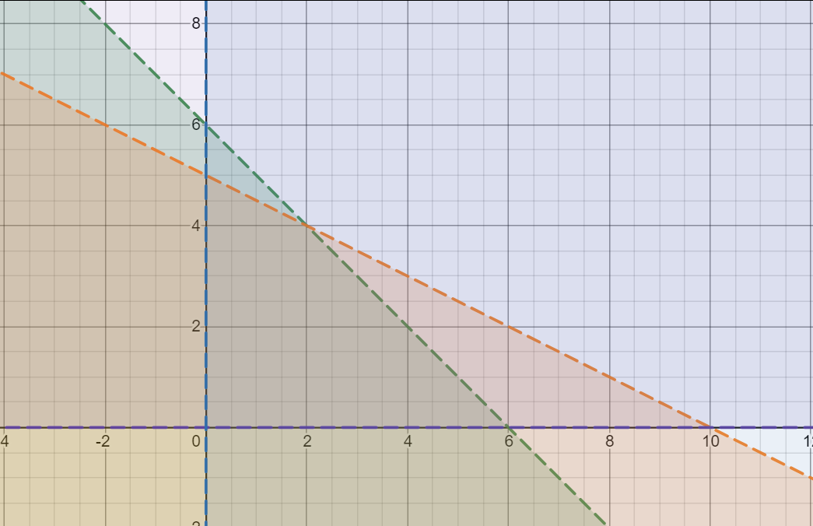

Figure : Graphic Representation of Linear Inequalities in Figure 2

Mathematicians developed the simplex method as one of the first ways to computationally solve real-world, or applicable, optimization problems. Since this time, various algorithms have emerged which may offer better results, depending on the type of problem. For example, the revised simplex method is mathematically equivalent to the simplex method, though it is computationally more efficient due to its storage requirements [7]. Operations research analysts typically use The Hungarian Method to solve assignment problems, which are a particular subgroup of mathematical optimization problems [9]. Many have used these types of algorithms to solve complex business questions.

# Literature Review

Both private and public industry have taken advantage of the algorithm illustrated above, as well as other mathematical optimization techniques, specifically for program management. Given that financial data is one of the most abundant data sources of the 20th century, it is no surprise that one of the first instances of mathematical modeling for program management occurred in the financial sector [10].

Harry Markowitz began using linear programming techniques in the 1950s while designing investment portfolios. Markowitz initially proposed using the simplex method to build an optimal securities portfolio, balancing risk and return as well as correlation and diversification [10]. Using basic probability theory and advanced mathematical optimization concepts, he changed the field of economics. Rather than using popular economic investment strategies, such as the dividend discount model or qualitative assessments of a company or a stock [11], he implemented linear programming algorithms to construct his portfolios. Markowitz later became the father of modern portfolio theory, maximizing the expected return of a particular portfolio given the level of accepted risk, and won a Nobel Prize for his work [12].

Many economists built off Marowitz’s seminal work, including Dimitris Bertsimas, Christopher Darnell, and Robert Soucy. In 1998, they used software developed for solving linear programming problems called CPLEX, or the simplex method in the C programming language. They introduced additional constraints, such as limiting the number of names and transactions within the portfolio to adequately manage a large portfolios. Using the results from their mathematical models to drive their investment decisions, they were able to significantly improve the firm’s performance [13].

The financial sector is not the only industry that has benefited from linear programming. Maia, Lago, and Qassim developed a linear programming model to support the preliminary design and facility planning for food presentation centers. They note, “the design of preservation facilities has been based on qualitative considerations, without a rigorous search for optimal solutions, in spite of the scarce availability of financial resources in the regions where food losses are greatest” [14, p. 85]. In their implementation, they emphasize assisting engineers in the facility design and overall project management using their model to improve a private agricultural business [14].

The construction industry has a strong foundation in cost analysis; a natural extension of this work is implementing operations research techniques to optimize efficiencies while reducing cost. While analyzing the vertical alignment phase of road design, researchers found integer programming minimized the cost of moving material between different road segments while adhering to building code and safety constraints [15]. Similarly, another analyst used linear optimization to assist decision-makers prioritize investments in pavement. Public works departments often use the “worst first” approach to prioritize pavement maintenance, whereby the pavement in the worst condition receives top priority for repair. Sindi used a mathematical model as a separate prioritization schema, and found a cost decrease and an increased service life of roads when compared to the current prioritization plan [16]. While linear programming has its use in private industries, various public entities enlisted linear programming to tackle the management of government projects.

Project managers within federal, state, and local governments have benefited from using linear programming to optimize their decision making. In Changchun City, China, researchers determined how to prioritize investments in wetland restoration projects using linear programming algorithms. Their model found higher ecological and socio-economic benefits than the original prioritization proposal, while maintaining a 6.84%-15.43% decrease in investment dollars [17]. Analysts also developed an advanced linear programming technique, called fuzzy-stochastic-interval linear programming, for a city in China to optimize the municipal solid waste (MSW) management system. Techniques applied to MSW management are broadly applicable to program management because MSW management involves the same priorities and considerations as any other program. MSW management requires the overseeing of waste generation sources, waste treatment, disposal facilities, and the cost of the system. The application of linear programming resulted in a decrease of system cost and an increase in system reliability [18].

The private and public sectors alike leverage mathematical optimization to assist in both project management and portfolio prioritization. They have determined how to improve current processes with linear programming techniques, and the NNSA may benefit from similar implementations.

# Application

Problem Statement and Setup

As stated in the introduction, the PRWG’s main goal is to create clear lines of communication and to limit funding redundancies. While this mission only contains a subset of program management tasks, the data the PRWG collects annually can assist with the larger task of portfolio management for programmatic equipment. Dedicated analysts from the Management and Budget Office support the PRWG program offices by offering analytical support. The Capability Based Investment (CBI) group, a team within a PRWG program office, posed the following question to the Management and Budget analysts:

When recapitalizing programmatic equipment, how can we buy down the greatest amount of risk while staying within the confines of our budget?

The idea of “buying down risk” can be difficult to quantify. Using the guidance provided by the DOE Risk Management Guide [19], the PRWG asks the M&O contractors to identify the risk to mission associated with each piece of equipment as a part of its annual data call. For each piece of programmatic equipment, M&O contractors reported two metrics: Risk to Mission (Impact) and Risk to Mission (Probability). Figure 4 depicts the guidance provided to the M&O contractors. When filling out the data call, the M&O contractors selected “Minimal”, “Minor”, “Moderate”, “Significant”, or “Severe” for Risk to Mission (Impact) for each individual piece of equipment. Similarly, they chose “Very Unlikely”, “Unlikely”, “Likely”, “Highly Likely”, or “Nearly Certain” for Risk to Mission (Probability) for each individual piece of equipment. The M&O contractors also reported the procurement cost (TY$) for each piece of equipment.

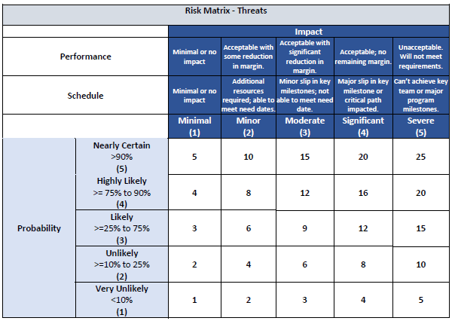

Figure : Risk Matrix Provided to the M&O Contractors by the PRWG

With a way to quantify risk and cost for each piece of equipment, analysts turned this question into a system of linear inequalities. The decision variables became the individual pieces of equipment, the budget represented the sole constraint. When looking to create an objective function, the question becomes “what must be optimized?” Based on this question above, the objective function should maximize the amount of risk bought down, which is expressed as a proportion:

$$Amount of Risk Bought Down= \frac{Sum of All Risk Purchased}{Sum of All Risk Present in the Portfolio}$$

Figure : Amount of Risk Bought Down Equation

As the sum of all risk present in the portfolio will not vary, the objective function will seek to optimize the sum of all risk purchased.

The following is an example of how this dataset transformed into a system of linear inequalities. For simplicity’s sake, only six pieces of equipment, labeled a through f, will be examined. Note there are two separate systems, using the Risk to Mission (Impact) score (abbreviated RTM_Impact) and the Risk to Mission (Probability) (abbreviated as RTM_Probability) score as two separate optimizers. The CBI group must provide a budget to constrain the budget for equipment procurement, hence the labeling of “Program Inputs”.

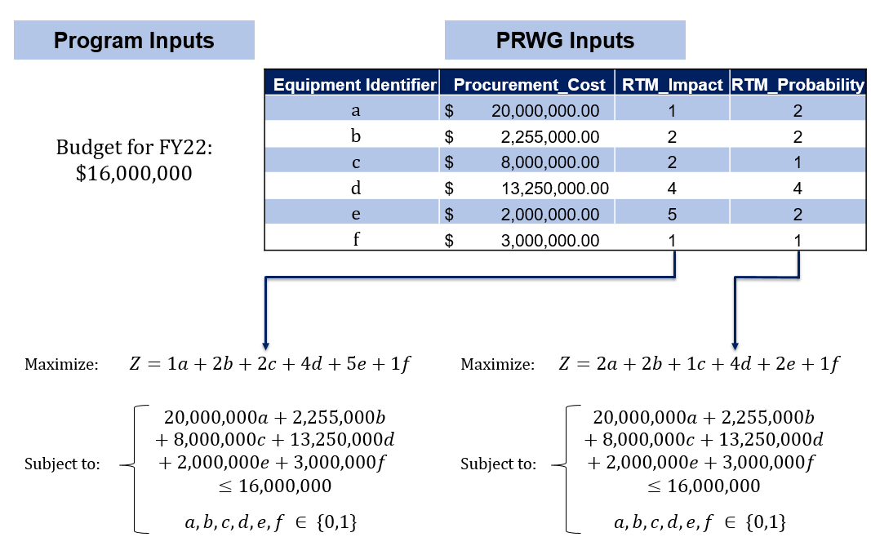

Figure : PRWG Data into a Linear System

Similar to Figure 1, the decision variables in Figure 6 act as independent variables in the objective function and the constraints. The first system’s objective function seeks to maximize the sum of RTM_Impact, whereas the second system’s objective function seeks to maximize the sum of RTM_Probability.

The coefficients in the objective function relate to the risk score of each piece of equipment. Similarly, the coefficients in the first constraint relate to the procurement cost of each piece of equipment, the sum of which must be less than or equal to the budget of $16,000,000.

The final constraint indicates this question is a binary programming problem, rather than a linear or integer programming problem. Without constraining our problem type to binary programming, one could optimize the first system by purchasing eight instances of equipment e. Buying down multiple instances of one piece of equipment does not meaningfully improve the nuclear posture; therefore, constraining the decision variables to be a 1 or 0 indicates whether the CBI group should purchase or not purchase, respectively.

Without this quantitative assessment, an M&O contractor may look at the Risk to Mission (Impact) score and communicate to a project manager that pieces of equipment d & e are the highest priority. However, by declining to purchase equipment d, the program manager has the ability to recapitalize pieces of equipment b, c, e & f. Using the secondary prioritization schema, the program manager has bought down more risk than relying on subject matter expert opinion alone. Figure 7 demonstrates this concept below, the optimized percentage increases and the remaining percentage decreases.

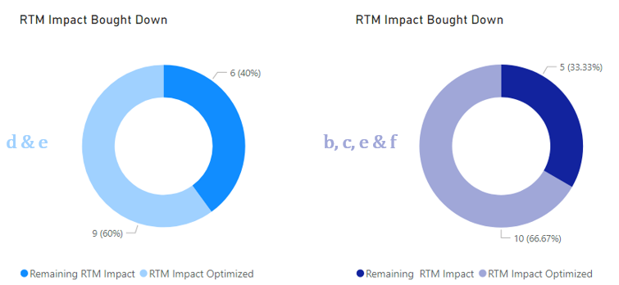

Figure : SME Prioritization Schema vs Optimal Prioritization Schema

A program manager may look at the price tag of equipment d and defer procurement until there is additional funding or less pieces of equipment to recapitalize in its place. What if the piece of equipment was slightly less expensive? At what price point would it become more viable to buy equipment d? What happens when the portfolio expands to tens or hundreds of pieces of equipment? These manual comparisons and sensitivity analyses are cumbersome as the portfolio increases, and adversely impacts the ability to make informed, data-driven decisions. The automation of binary programming algorithms addresses these questions quickly and easily.

Model Development

The PRWG’s dataset contains over 3,000 pieces of equipment, managed by over fifteen program offices. To assist the CBI group, the analysts first subset the data to home in on CBI’s equipment. Then a column is chosen to create the objective function, e.g. Risk to Mission (Impact) or Risk to Mission (Probability). For this paper’s purpose, the chosen metric is designated as the optimizer. The PRWG’s dataset has gaps, some columns have null entries. However, removing all rows with null columns discards equipment that requires recapitalization. To retain the most data possible for the model, nulls are removed only after the optimizer is chosen. The model was implemented in R using lp_solve as the underlying binary programming solver. The lpSolve algorithm, developed initially by Michel Berkelaar and maintained by Gábor Csárdi [20], employs the revised simplex method [21]. Figure 8 represents the output of the model identified in Figure 6.

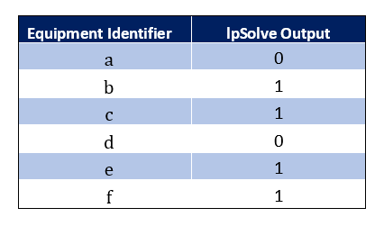

Figure : First Model Run Output

This output ties directly to the specified optimizer, using a different optimizer may result in a different selection. Rather than selecting a single optimizer, the team ran multiple optimizers and compared them side-by-side. Risk to Mission (Impact) and Risk to Mission (Probability) can be optimized independently, or can be combined into a singular Risk to Mission Score as an optimizer. Other metrics for consideration from the PRWG data set included Equipment Utilization and Expected Remaining Life. Figure 9 presents the output from running binary programming across three different variables.

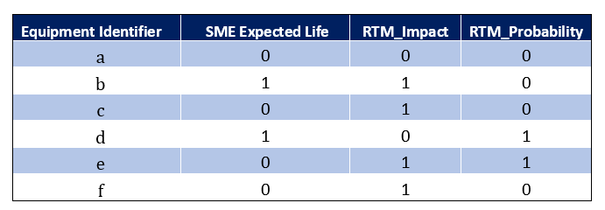

Figure : Three Model Runs Output

Similar to many instances in the literature, the output shown above is not a directive for the CBI team, but rather an asset. There is no one singular metric or optimizer that can confidently select the correct pieces of equipment to procure without human oversight and input. Mathematical optimization can aide the decision-making process, and ensure parties are informed on the number of possibilities present. Importantly, it provides a starting point for conversations with M&O contractors. For example, the sample output above begs the following two questions. Why is equipment b not a priority for the enterprise when it was selected as often as d & e? If CBI chooses to pass over d, what is the possibility the M&Os can execute c, e & f successfully? These conversations lead to bigger questions, such as what are downstream implications for passing over certain purchases? If CBI does not purchase a particular piece of equipment this year, when should it be procured?

One can use linear programming to address the last question. Figures 10 – 13 below demonstrate the process using a single optimizer, Risk to Mission (Impact). Figure 10 has the same set up as Figure 6, where the FY22 budget acts as the right-hand side of the constraint, the procurement costs are the left-hand side of the constraint, and the RTM_Impact score is the objective function. After running the lpSolve algorithm, the binary program returns the output shown in Figure 11.

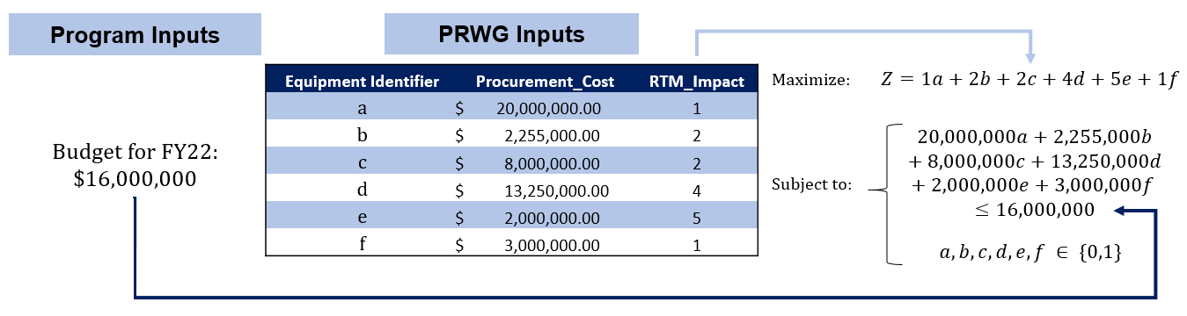

Figure : Binary Programming Setup on Risk to Mission (Impact) for FY22



Figure : Binary Program Output for FY22

Next, filter out any pieces of equipment selected in FY22 by removing any piece of equipment from the dataset with a 1 in the lpSolve Output column. Then, construct the problem once more on the remaining subset of the data. CBI must provide their budget estimate for the next fiscal year, FY23. For this example, a 2% inflation rate is applied to the procurement cost for the individual pieces of equipment. The escalated dataset, seen in Figure 12, becomes the new foundation of the linear program. Note the FY23 budget acts as the right-hand side of the constraint, the procurement costs are the left-hand side of the constraint, and the RTM_Impact score is the objective function.

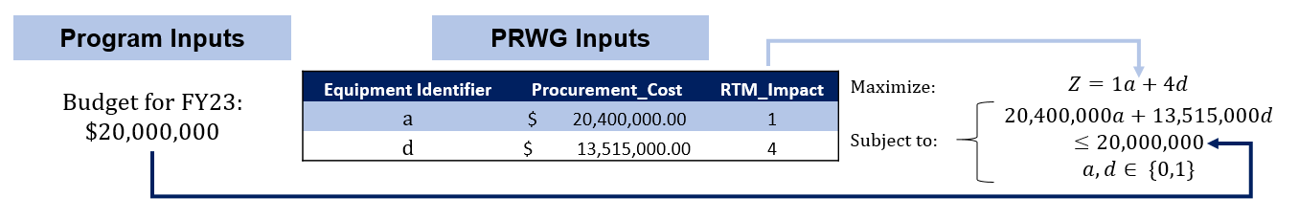

Figure : Binary Programming Setup on Risk to Mission (Impact) for FY23

Run the lpSolve algorithm once more to obtain the selection for FY23, and obtain the output seen in Figure 13. One could optimize problem outlined in Figure 12 with the naked eye; keep in mind this example had only six pieces of equipment in the starting dataset. In reality, CBI is responsible for recapitalizing hundreds of pieces of equipment, so the optimization is too cumbersome to calculate manually.

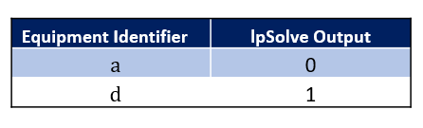

Figure : Binary Output for FY23

There are additional problems that render these optimal scenarios unrealistic in practice. There are some contractual obligations or mission needs necessitating the procurement of certain pieces of equipment in a particular year. There are some equipment procurements that rely on other equipment to support a capability or a project, which means procuring one without the other would not make logical sense. Many of these business rules can be built into the model as additional constraints, but this requires knowledge of all business rules ahead of time. While this may appear to be a limitation of mathematical optimization, it actually illustrates why human oversight and interaction with model outputs is crucial.

Future iterations of this work will include building these business rules into the constraints of the linear system, leveraging key performance indicators from other datasets as optimizers for comparison, and accounting for other costs outside of procurement costs. Total acquisition cost can be up to twice the amount of equipment procurement when accounting for installation, tooling, testing, and other associated costs. These costs are often phased over time, rather than all in one fiscal year.

Results

The CBI program manager has used the linear programming model to begin building optimal budget scenarios, and comparing them to current qualitative plans.. The analysts in the Programming, Analysis, and Evaluation office have presented the optimization model to various M&O contractors, and all have shown support for this type of data-driven decision support. The CBI team is building this analysis into their risk management strategy, and will help remove subjectivity from the prioritization process. The CBI team is responsible for equipment across the enterprise, and can use the results to weigh competing priorities from different M&O contractors.

In addition, the CBI team has proposed using linear programming as a way to form budget proposals. By varying the budget within the same year, the program manager can understand how much additional risk is bought down with funding increases, and how much risk will be left within the enterprise with funding decreases. By creating functions in R to rerun the model with adjustable budget inputs, and creating visualizations of the data in PowerBI, the CBI team could identify budgetary impacts in real time. Though the linear programming outputs are not determinative, the CBI team can use this data to make informed decisions, and clearly communicate proposals to leadership.

# Conclusion

Given the DOE’s wide variety of missions and priorities, the Nuclear Security Enterprise requires the ability to make informed, data-driven decisions. As the CBI case study demonstrates, linear programming is a powerful tool to assist program managers in portfolio prioritization and program management. The simplex method and its counterparts provide an opportunity for crafting optimal budget scenarios using the PRWG data.

Though these scenarios converge to a solution which buys down the most risk for the enterprise, they are often not realistic for an agency undergoing modernization with consistently changing requirements. For this reason, it is essential that program managers and analysts review the model outputs thoroughly, establish business rules to build into the model, and use the outputs as a framework rather than an exact recapitalization plan.

Linear programming offers federal program managers a credible, defensible approach to initiate data-driven discussions with M&O contractors about competing priorities, to communicate how their funding directly impacts that amount of risk bought down, and to ultimately make informed decisions across their portfolio.

# References

|  |  |
| --- | --- |
| [1] | D. C. Trimble, "DOE Facilities: Better Prioritization and Life Cycle Cost Analysis Would Improve Disposition Planning," 19 March 2015. [Online]. Available: gao.gov/products/gao-15-272. [Accessed 23 November 2019]. |
| [2] | M. Gaffigan, "Priority Open Recommendations: Department of Energy," 30 June 2021. [Online]. Available: https://www.gao.gov/products/gao-21-597pr. [Accessed 3 12 2021]. |
| [3] | A. B. Bawden, "NNSA's Modernization Efforts Would Benefit from a Portfolio Management Approach," 3 March 2020. [Online]. Available: https://www.gao.gov/assets/gao-20-443t.pdf. [Accessed 16 December 2021]. |
| [4] | Department of Energy, "REAL PROPERTY ASSET MANAGEMENT," 17 September 2020. [Online]. Available: https://www.directives.doe.gov/directives-documents/400-series/0430.1-BOrder-c-chg2-adminchg/@@images/file. [Accessed 2022 January 16]. |
| [5] | Department of Energy, "U.S. Department of Energy Information Resources Management Strategy," May 2021. [Online]. Available: https://www.energy.gov/sites/default/files/2021-05/FY%202018-2022%20DOE%20IRM%20Strategy.pdf. [Accessed 20 January 2022]. |
| [6] | W. A. Bookless and D. Brouillette, "Fiscal Year 2021 Stockpile Stewardship and Management Plan – Biennial Plan Summary: Report to Congress," December 2020. [Online]. Available: https://www.energy.gov/sites/default/files/2020/12/f82/FY2021_SSMP.pdf. [Accessed 2 January 2021]. |
| [7] | G. Sierksma and Y. Zwols, Linear and Integer Optimization Theory and Practice, Third Edition, Boca Raton: CRC Press, 2015. |
| [8] | M. Goemans, "Linear Programming: 18.310A Lecture Notes," 17 March 2015. [Online]. Available: https://math.mit.edu/~goemans/18310S15/lpnotes310.pdf. [Accessed 17 December 2021]. |
| [9] | H. W. Kuhn, "The Hungarian method for the assignment problem," *Naval Research Logistics Quarterly,* vol. 2, no. 1-2, pp. 83-97, 1955. |
| [10] | H. M. Markowitz, "A Simplex Method for the Portfolio Selection Problem," *Cowles Foundation Discussion Papers,* vol. 3, no. 1, p. 224, 1957. |
| [11] | J. B. Williams, The Theory of Investment Value, Boston: Harvard University Press, 1938. |
| [12] | H. M. Markowitz, Portoflio Selection, Cowles Commission Papers: The University of Chicago, 1952. |
| [13] | D. Bertsimas, C. Darnell and R. Soucy, "Portfolio construction through mixed integer programming," *Institute for Operations Research and the Management Sciences,* vol. 29, no. 1, pp. 49-66, 1999. |
| [14] | L. O. A. Maia, R. A. Lago and R. Y. Qassim, "Selection of postharvest technology routes by mixed-integer linear programming," *International Journal of Production Economics,* vol. 49, no. 2, pp. 85-90, 1997. |
| [15] | W. Hare, Y. Lucet and F. Rahman, "A mixed-integer linear programming model to optimize the vertical alignment considering blocks and side-slopes in road construction," *European Journal of Operational Research,* vol. 241, no. 3, pp. 1-11, 2015. |
| [16] | W. K. Sindi, "A Decision Support Methodology for Pavement Condition Assessment and Project Prioritization of Infrastructure Asset Managemnt. A Case Study in Yanbu Industrial City," The Catholic University of America, Washington, D.C., 2018. |
| [17] | B. Cai, Y. Zhang, X. Wang and Y. Li, "An Optimization Model for a Wetland Restoration Project under Uncertainty," *International Journal of Enviornmental Research and Public Health,* vol. 15, no. 12, p. 2795, 2018. |
| [18] | P. Li and B. Chen, "FSILP: Fuzzy-stochastic-interval linear programming for supporting municipal solid waste management," *Journal of Enviornmental Management,* vol. 92, no. 4, pp. 1198-1202, 2011. |
| [19] | Office of Management, Department of Energy, "Risk Management Guide," 16 September 2008. [Online]. Available: https://www.directives.doe.gov/directives-documents/400-series/0413.3-EGuide-07/@@images/file. [Accessed 10 January 2022]. |
| [20] | G. Csárd, "Package ‘lpSolve’," CRAN, 24 January 2020. [Online]. Available: https://cran.r-project.org/web/packages/lpSolve/lpSolve.pdf. [Accessed 19 January 2022]. |
| [21] | Massachusetts Institute of Technology, "Introduction to lp_solve 5.5.2.5," [Online]. Available: http://web.mit.edu/lpsolve/doc/. [Accessed 15 January 2022]. |